**Activity 3: Dinosaur skeleton**

Find out about Dippy’s skeleton and compare the shape and size of some of his body parts to your own.

**Learning outcomes**

Children will:

* recognise that dinosaurs and humans share a similar body structure, with a spine, four limbs, a ribcage and a skull
* be able to name and identify the positions of the spine, ribcage, skull, arms and legs on their own bodies and on a picture of a skeleton
* be able to identify parts of a dinosaur skeleton and relate these to associated parts of the human body
* be able to identify and describe the differences between a human and a *Diplodocus* skeleton

**Resources required**

Provided in the Natural History Museum package:

* drawing of a *Diplodocus* skeleton
* worksheets

Provided by school:

* printing
* scissors
* writing materials
* glue or sticky dots
* full-length mirror, if possible

**Background**

Dippy is a *Diplodocus*, a large herbivorous (plant-eating) dinosaur. He lived on the land that is now Wyoming in the USA during the Jurassic Period, about 150 million years ago.

The fossil bones were discovered by workmen digging a railway, and excavated by scientists in 1898.

**Activity 3: Dinosaur skeleton**

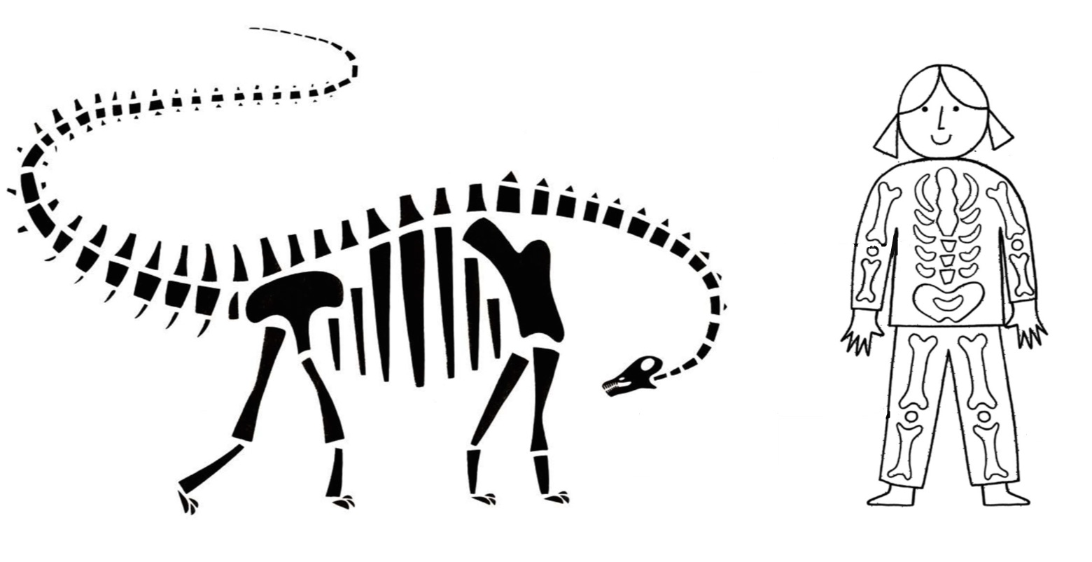

**Ribs**

**Knee**

**Leg**

**Skull**

**Spine**

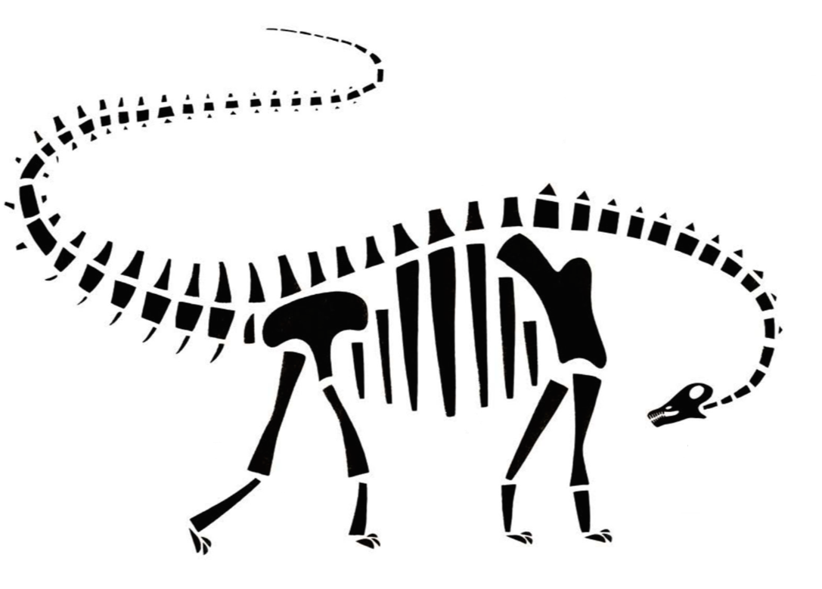

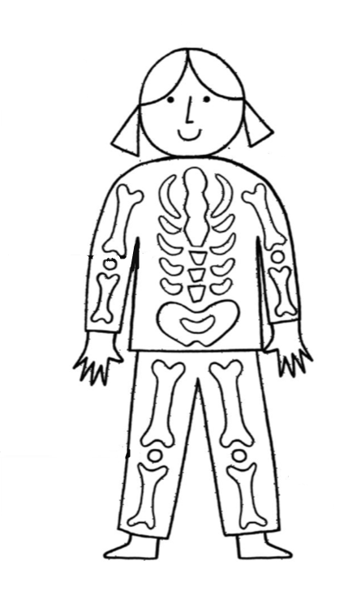

**Activity 3: Teacher notes**

Tell the children that palaeontologists (scientists who study fossils, including dinosaurs) put the *Diplodocus* bones that Dippy is cast from back together after they were carefully excavated from the rocks in which they were fossilised. The bones did not stay in the perfect position because the ground they were in moved about before the bones became fossilised. Scientists compared the bones to bones from animals alive today to help them to identify them.

Most animals with a backbone have a similar number of bones with similar functions, so we have bones in common with Dippy.

Look at and read the labels for different body parts. Can the children identify these features on their own bodies?

Cut out and stick the labels in the right place to identify the different body parts on the drawing of Dippy. Encourage the children to stand like Dippy (on all fours) to help them understand the different posture.

Ask the children to think about the similarities and differences between their bones and Dippy’s bones. How is Dippy’s body different to theirs?

* You could ask the class to trace around the flesh outline (or print a second copy with a blank reverse side) of the dinosaur shape to cut out. Use the plain side to draw on external body details and colour Dippy in. Stick the skin over the bones to give a flap-open version of the dinosaur so that both skeleton and external body parts are labelled.
* You could discuss why the children chose the colours or patterns they used to decorate Dippy and link this to habitat.
* You could ask the children to use a full-length mirror or work in pairs to identify the parts on their bodies that they have labelled on Dippy. Use post-its to label each other then check in with other pairs to self-assess, or draw portraits of each other or self-portraits to add labels to.

**English curriculum links (Key Stage 1)**

**Science: Animals, including humans**

Pupils should be taught to:

* describe and compare the structure of a variety of common animals (fish, amphibians, reptiles, birds and mammals, including pets)
* identify, name, draw and label the basic parts of the human body and say what part of the body is associated with each sense

**Northern Irish curriculum links (Foundation Phase and Key Stage 1)**

**The world around us**

**Interdependence**

Pupils should be enabled to explore:

* Who am I?
* What am I?
* Am I the same as everyone else?
* What else is living?
* How do living things survive?

**Progression**

As pupils progress through the Foundation Stage they should be enabled to:

* identify similarities and differences between living things, places, objects and materials

**Scottish curriculum links (Early and First)**

**Sciences: Experiences and outcomes**

**Biological systems: Body systems and cells**

By researching, I can describe the position and function of the skeleton and major organs of the human body and discuss what I need to do to keep them healthy. **SCN 1–12a**

**Welsh curriculum links (Foundation Phase)**

**Knowledge and understanding of the world: Range   
Myself and other living things**

Children should be given opportunities to:

* learn the names and uses of the main external parts of the human body and plants
* observe differences between animals and plants, different animals, and different plants in order to group them
* identify the similarities and differences between themselves and other children

