**Activity 1: Dinosaur timeline**

Make an arm-span timeline to help visualise time.

**Learning outcomes**

Children will:

* learn a strategy for thinking about very long periods of time that can be applied to other aspects of history
* understand that non-avian dinosaurs lived long before humans – they did not live together
* understand that Earth is more ancient than dinosaurs
* understand that humans have lived for a very short time compared to the age of the planet

**Resources required**

Provided in the Natural History Museum package:

* illustrated instructions

Provided by school:

* printing
* string
* parcel tags

**Background**

**When did dinosaurs live?**

Dinosaurs lived in the Mesozoic Era, during the Triassic, Jurassic and Cretaceous periods.

*Diplodocus*: 155–145 million years ago

*Iguanodon*: 129–120 million years ago

*Hypsilophodon*: 129–125 million years ago

*Tyrannosaurus rex*: 68–66 million years ago

*Albertosaurus*: 70–66 million years ago

*Velociraptor*: 75–72 million years ago

Looking at these dates, we know that *Diplodocus* would never have been hunted by a *T. rex*!

Earth is 4.55 billion years old and the earliest fossils are about 3.6 billion years old. This means that dinosaurs lived quite recently compared to trilobites and the early ancestors of fish.

The very first hominins (human ancestors) evolved around seven million years ago, and modern humans have only existed for 200,000 years. Animals like us have been on the planet for less time than *T. rex* existed!

Humans and non-avian dinosaurs have never been alive at the same time.

**Activity 1: Dinosaur timeline**

**66 million years** Non-avian dinosaurs go extinct

**230 million years** Dinosaurs evolve

**4.28 billion years** Age of the oldest fossils ever found

**200,000 years** Early humans evolve

**4.55 billion years** Earth formed

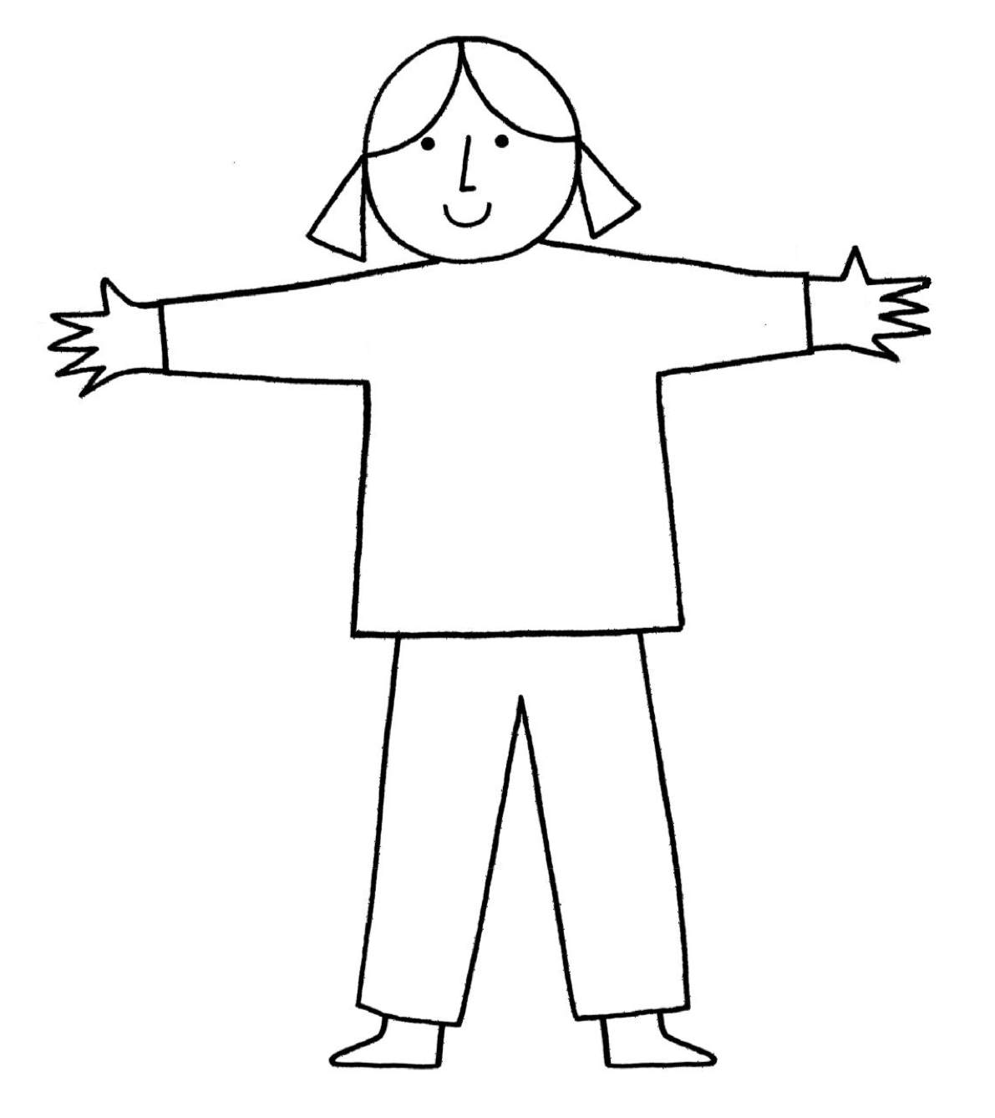

**Activity 1: Teacher notes**

Children could work in pairs and do this themselves, or you could model this with one child or yourself.

Stretch out your arms to represent the whole age of Earth, from right-hand fingertip to left-hand fingertip. First life starts at your right armpit – this is the age of the oldest fossils ever found. Dinosaurs start at the crease of your left wrist and end where your middle finger starts. The earliest humans evolve just below the tip of your middle finger of your left hand.

* you could choose one child to demonstrate this to the class and stretch a string or length of fabric across the arm span and use clothes pegs or glue to add pictures
* you could research other events in Earth’s history from books and make a number line for the history of Earth
* you could apply this timeline technique to other historical events to help children visualise the time differences between other events in local, national or international history

**English curriculum links (Key Stage 1)**

**Maths**

**Measurement**

Pupils should be taught to:

* compare, describe and solve practical problems for: time [for example, quicker, slower, earlier, later]
* measure and begin to record the following:

sequence events in chronological order using language [for example, before and after, next, first, today, yesterday, tomorrow, morning, afternoon and evening]

* recognise and use language relating to dates, including days of the week, weeks, months and years

**Northern Irish curriculum links (Foundation Phase and Key Stage 1)**

**Foundation: Mathematics and numeracy**

**Measures**

Pupils should be enabled to:

* sequence two or three familiar events
* compare two intervals of time and talk about their observations in terms of took longer/shorter time
* explore time patterns
* choose and use, with guidance, non-standard units to measure time and talk about their work

**Scottish curriculum links (Early and First)**

**Numeracy: Experiences and outcomes**

**Number money and measure:** **Number and number process**

I have explored numbers, understanding that they represent quantities, and I can use them to count, create sequences and describe order. **MNU 0–02a**

**Information handling: Data analysis**

I can collect objects and ask questions to gather information, organising and displaying my findings in different ways. **MNU 0–20a**

I can match objects, and sort using my own and others’ criteria, sharing my ideas with others. **MNU 0–20b**

I have explored a variety of ways in which data is presented and can ask and answer questions about the information it contains. **MNU 1–20a**

I have used a range of ways to collect information and can sort it in a logical, organised and imaginative way using my own and others’ criteria. **MNU1–20b**

**Welsh curriculum links (Foundation Phase)**

**Mathematical development**

Using measuring skills – time.

Dippy on Tour – Resources for ages 4–7 **Activity 1: Dinosaur timeline** 4

